15.58: The speed of light is so large compared to the speed of sound that the travel time of the light from the lightning or the radio signal may be neglected. Them, the distance from the storm to the dorm is 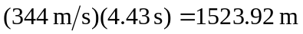 and the distance from the storm to the ballpark is 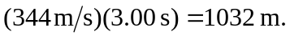 The angle that the direction from the storm to the ballpark makes with the north direction is found from these distances using the law of cosines;

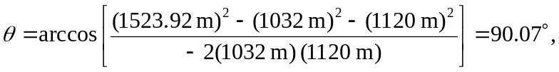

so the storm can be considered to be due west of the park.

